**NAME:- Nitesh Bovi**

**CLASS:- D14B ROLL NO:-07**

**AIM:-**To install linux based operating system using network installation method

**APPARATUS:-**PC with operating system

**THEORY:-**

**What is LINUX?**

Linux is an [open source](https://www.redhat.com/en/topics/open-source/what-is-open-source) operating system (OS). An [operating system](https://www.redhat.com/en/technologies/linux-platforms/old-enterprise-linux) is the software that directly manages a system’s hardware and resources, like CPU, memory, and [storage](https://www.redhat.com/en/topics/data-storage/software-defined-storage). The OS sits between applications and hardware and makes the connections between all of your software and the physical resources that do the work.

**How does Linux work?**

Think about an OS like a car engine. An engine can run on its own, but it becomes a functional car when it’s connected with a transmission, axles, and wheels. Without the engine running properly, the rest of the car won’t work.

[Linux](https://www.redhat.com/en/topics/linux) was designed to be similar to UNIX, but has evolved to run on a wide variety of hardware from phones to [supercomputers](https://www.redhat.com/en/blog/red-hat-enterprise-linux-builds-foundation-worlds-fastest-supercomputers). Every Linux-based OS involves the [Linux kernel](https://www.redhat.com/en/topics/linux/what-is-the-linux-kernel)—which manages hardware resources—and a set of software packages that make up the rest of the operating system. Organizations can also choose to run their Linux OS on a [Linux server](https://www.redhat.com/en/topics/linux/linux-server).

The OS includes some common core components, like the [GNU tools](https://www.gnu.org/gnu/linux-and-gnu.en.html), among others. These tools give the user a way to [manage the resources](https://www.redhat.com/en/engage/why-linux-management-s-202011190256) provided by the kernel, install additional software, configure performance and security settings, and more. All of these tools bundled together make up the functional operating system. Because Linux is an open source OS, combinations of software can vary between Linux distributions.

**UBUNTU**

Ubuntu is a popular free and open-source Linux-based operating system you can use on a computer or Virtual Private Server.

**Ubuntu (pronounced oo-BOON-too) is an** [**open source**](https://www.techtarget.com/whatis/definition/open-source)[**Debian**](https://www.techtarget.com/searchdatacenter/definition/Debian)**-base** [**Linux**](https://www.techtarget.com/searchdatacenter/definition/Linux-operating-system) **distribution. Sponsored by Canonical Ltd., Ubuntu is considered a good** [**distribution**](https://www.techtarget.com/searchdatacenter/definition/distribution) **for beginners. The operating system was intended primarily for** [**personal computer**](https://www.techtarget.com/whatis/definition/personal-computer-PC)**s (PCs) but it can also be used on** [**server**](https://www.techtarget.com/whatis/definition/server)**s. The word "ubuntu" is from the African Zulu language and translates as "humanity to others."**

**The primary version of Ubuntu employs** [**GNOME**](https://www.techtarget.com/searchdatacenter/definition/GNOME-GNU-Network-Object-Model-Environment) **(GNU Network Object Model Environment, pronounced gah-NOHM), a graphical user interface (**[**GUI**](https://www.techtarget.com/whatis/definition/GUI)**) and set of desktop** [**application**](https://www.techtarget.com/searchsoftwarequality/definition/application)**s for Linux. GNOME is intended to make Linux easy to use for non-programmers and is similar to the** [**Windows**](https://www.techtarget.com/searchwindowsserver/definition/Windows) **desktop interface.**

**3 WAYS TO INSTALL UBUNTU:-**

**1) USING HARD DRIVE**

The benefit of installing an Ubuntu operating system on an external hard drive is that you may use and switch between Windows and Ubuntu without compromising storage space. Furthermore, you can now take this hard drive with you everywhere you go and connect it to any computer. You may continue working with your familiar OS and apps as long as you know how to set up the BIOS/UEFI so that it can boot. Another advantage is that if you botch up the installation, you can easily erase the disk and start again. This may be scary if you’re attempting to install Ubuntu on a partition on your local storage.

**2)INSTALLATION USING CONFIGURATION FILES**

1. Download an Ubuntu Image.
2. Create a Bootable USB stick.
3. Boot from USB flash drive.
4. Installation Setup.
5. Drive Management.
6. (Optional) Enable Encryption.
7. Choose your Location.
8. Create Your Login Details.
9. Complete the installation.
10. Update
11. Ubuntu installed!

# **3)NETWORK INSTALLATION METHOD**

# **Download an Ubuntu Image**

Make sure to save it to a memorable location on your PC! For this tutorial, we will use the latest Ubuntu 22.10 release.

[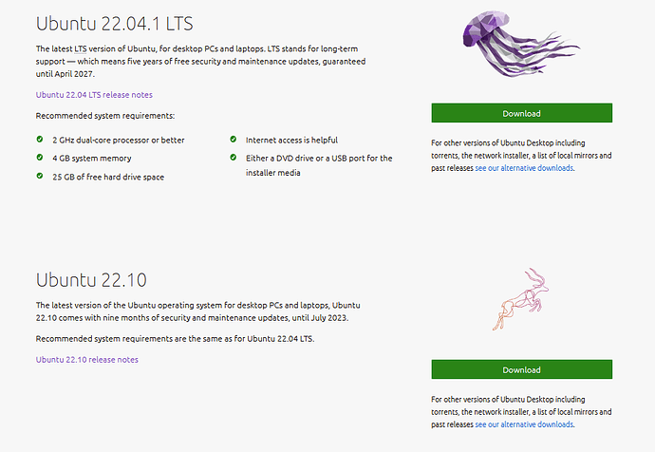](https://ubuntucommunity.s3.dualstack.us-east-2.amazonaws.com/original/3X/b/5/b58c62a68cbe82095e2625b8dd3d0d19769fd71c.png)

# **Download and install VirtualBox**

Once you have completed the installation, go ahead and run VirtualBox.

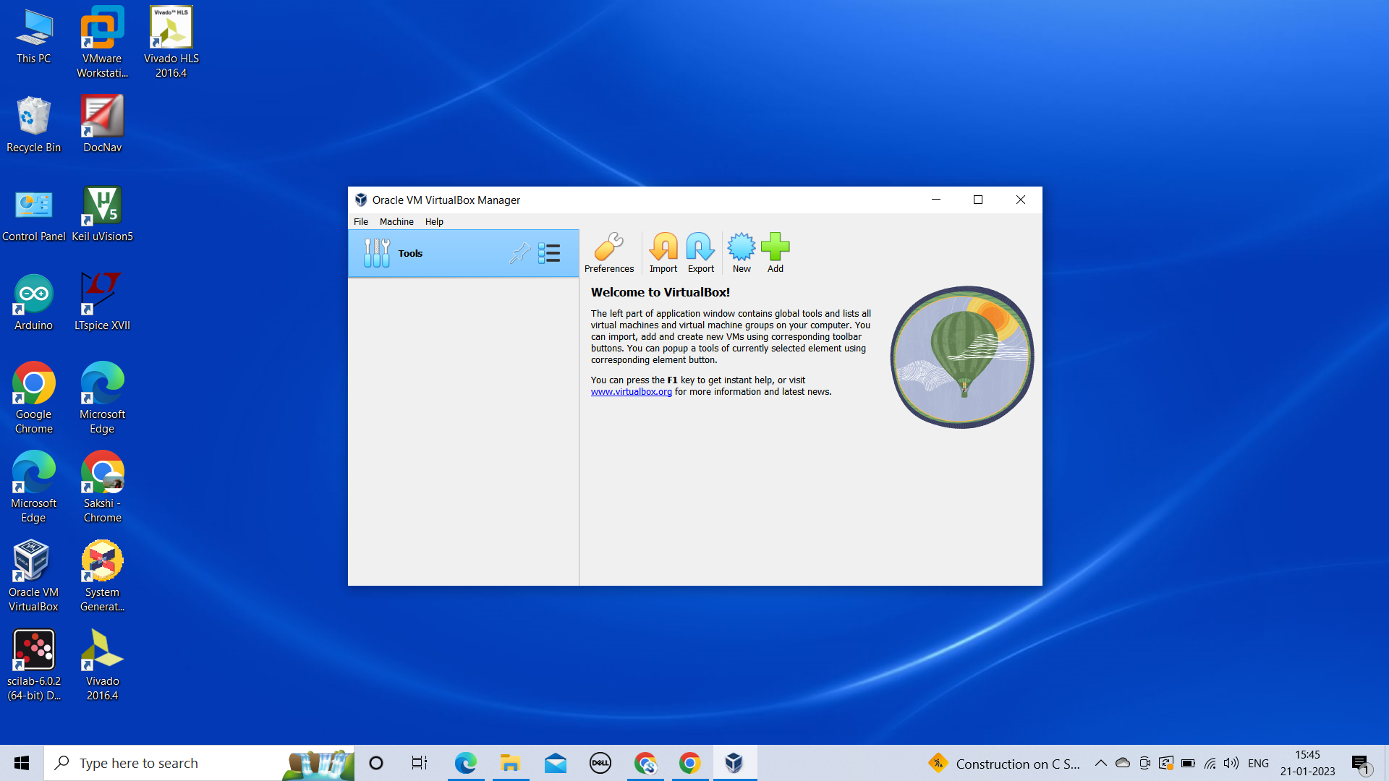

**Create a new virtual machine**

Click New to create a new virtual machine. Fill in the appropriate details:

* Name: If you include the word Ubuntu in your name the Type and Version will auto-update.
* Machine Folder: This is where your virtual machines will be stored so you can resume working on them whenever you like.
* ISO Image: Here you need to add a link to the ISO you downloaded from the Ubuntu website.

We want to install Ubuntu unattendedly so we can leave the checkbox to skip unchecked.

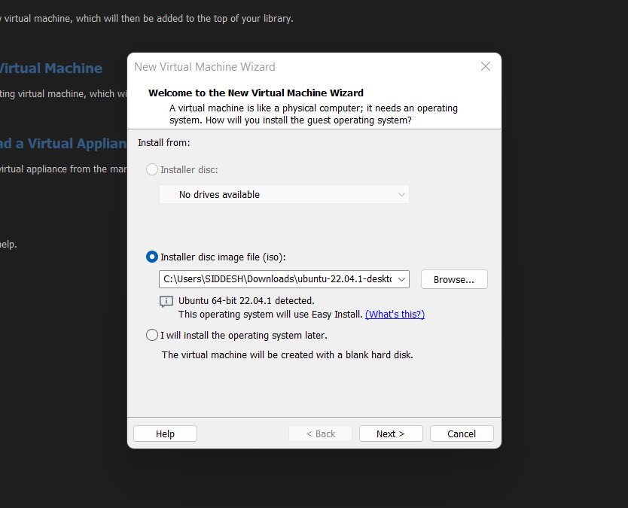

### **Create a user profile**

To enable the automatic install we need to prepopulate our username and password here in addition to our machine name so that it can be configured automatically during first boot.

The default credentials are:

* Username: vboxuser
* Password: changeme

Ensure your Hostname has no spaces to proceed!

It is also recommended to check the **Guest Additions** box to install the default Guest Additions ISO that is downloaded as part of VirtualBox. Guest additions enables a number of quality of life features such as changing resolution and dynamic screen resizing so it is highly recommended!

### **Define the Virtual Machine’s resources**

In the next section we can specifiy how much of our host machine’s memory and processors the virtual machine can use. For good performance it’s recommended to provide your VM with around 8GB of RAM (although 4GB will still be usable) and 4 CPUs. Try to remain in the green areas of each slider to prevent issues with your machine running both the VM and the host OS.

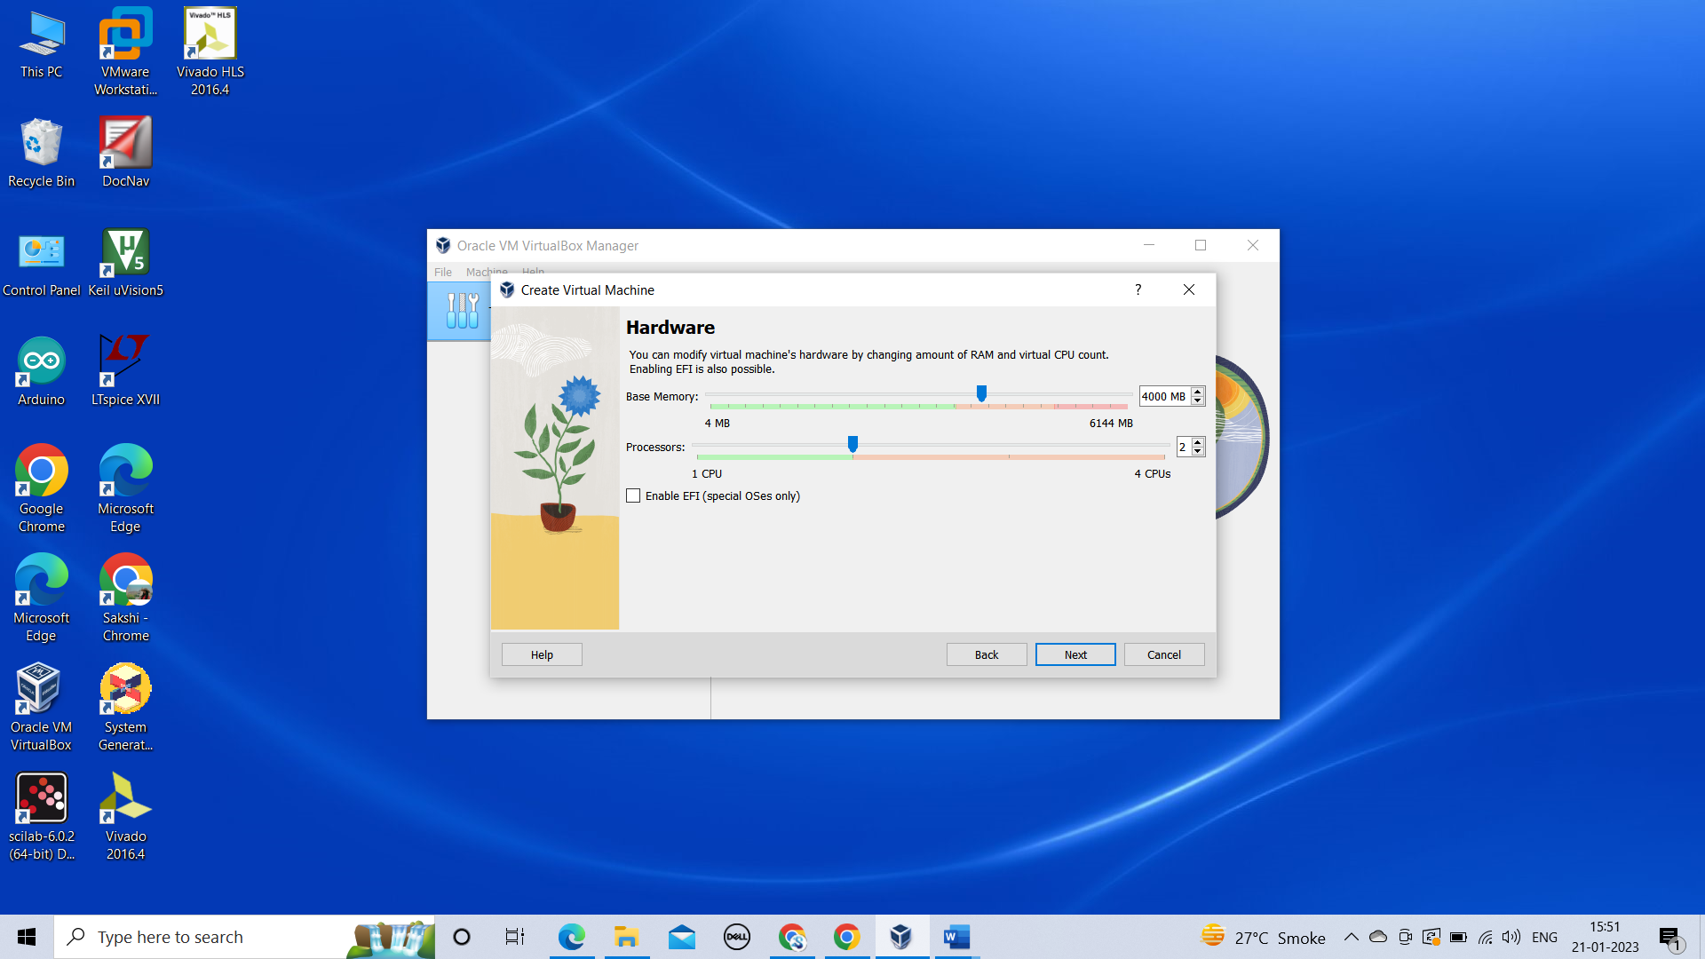

Then we need to specify the size of the hard disc for the virtual machine. For Ubuntu we recommend around 25 GB as a minimum. By default the hard disk will scale dynamically as more memory is required up to the defined limit. If you want to pre-allocate the full amount, check the ‘Pre-allocate Full Size’ check box. This will improve performance but may take up unnecessary space.

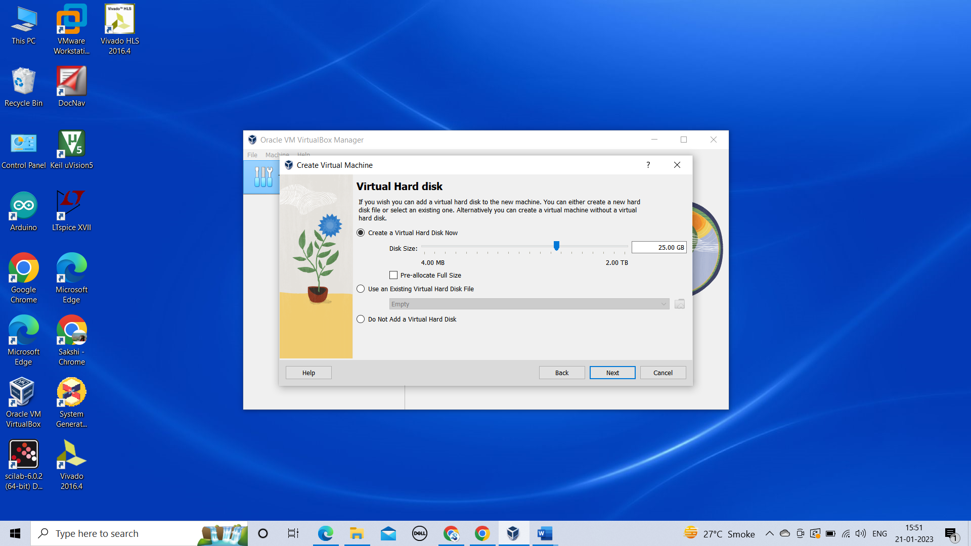

Click **Next** to continue and view a summary of your machine setting.

After this click **Finish** to initialize the machine!

## Install your image

Click **Start** to launch the virtual machine.

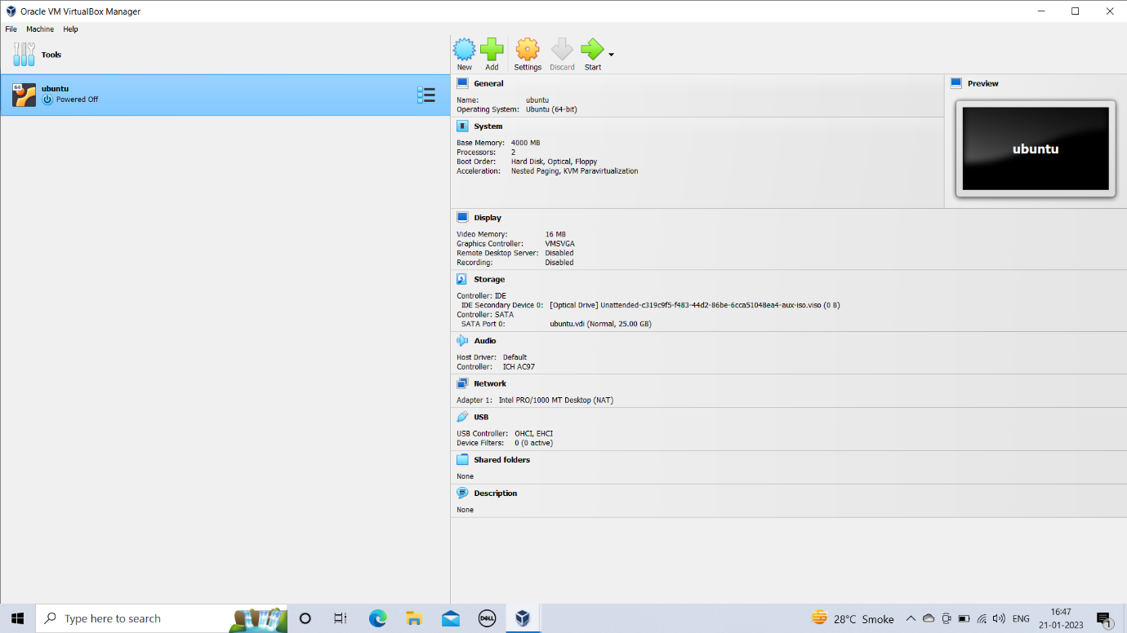

You will see a message saying ‘Powering VM up …’ and your desktop window will appear.

On first boot the unattended installation will kick in so do not interact with the prompt to ‘Try and Install Ubuntu’ and let it progress automatically to the splash screen and into the installer.

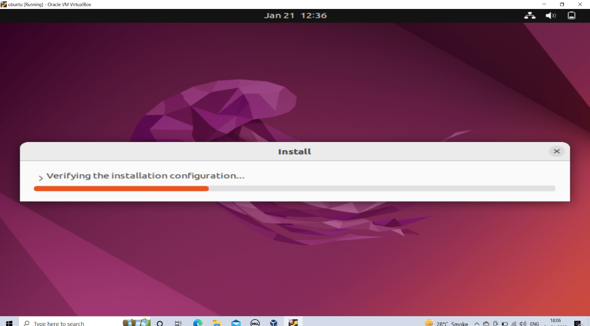

You will notice at this stage that the resolution of the window is fixed at 800x600. This is because the Guest Additions features are not installed until after the Ubuntu installation has completed.

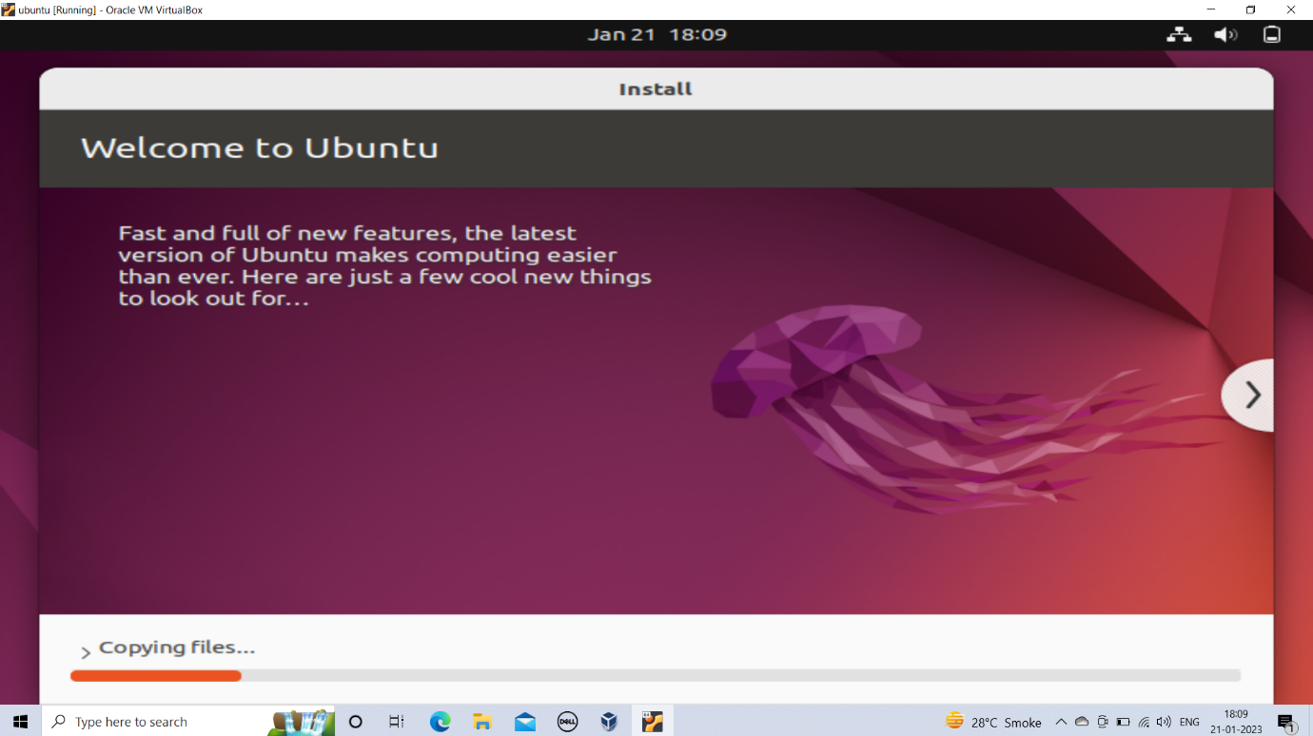

Once the installation completes, the machine will automatically reboot to complete the installation.

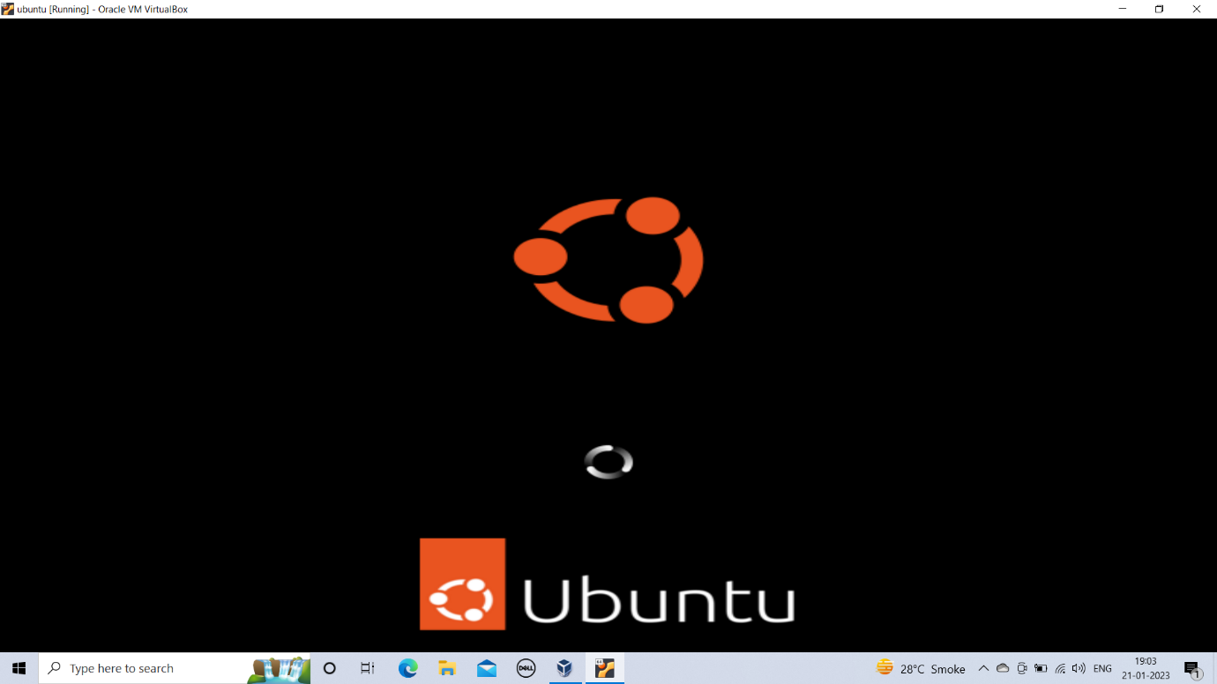

Finally you will be greeted with the Ubuntu log-in screen where you can enter your username and password defined during the initial setup

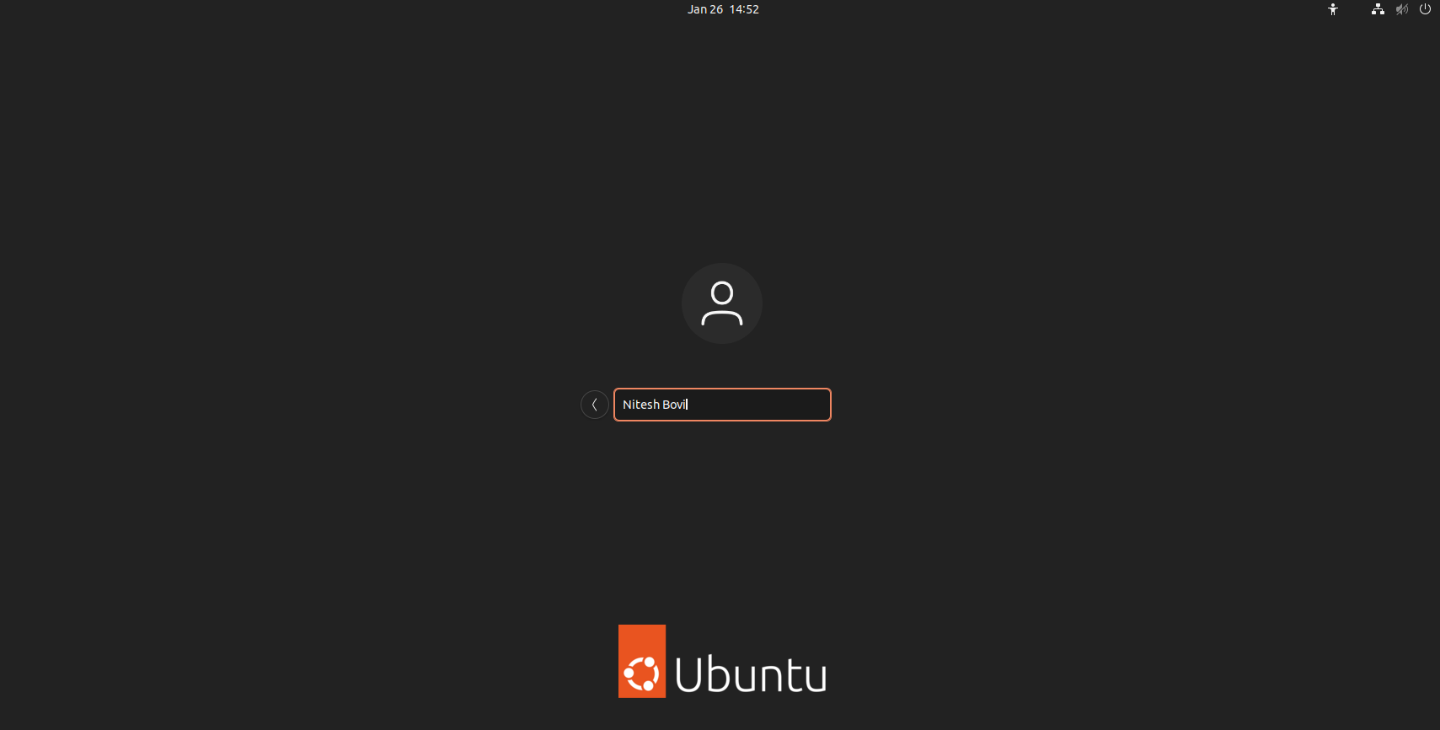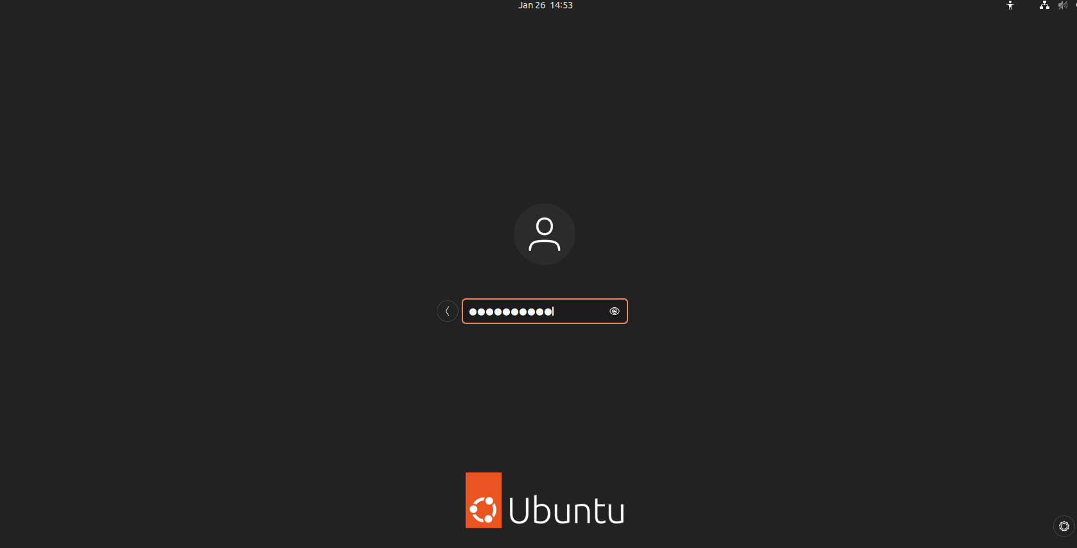

## Explore Virtual Box

Enjoy your shiny new Ubuntu Desktop!

